**LEMONJAX CRUD Exam**

1. Create a new database named “dbCrud”
2. On this database, create a table named “Users” with the following columns:

UserID – Primary key, Index Specification – (Is Identity) Yes

FirstName – nvarchar(50)

LastName – nvarchar(50)

Birthday - date

Email – nvarchar(100)

UserType – nvarchar(20)

Status – nvarchar(20)

DateAdded – datetime

1. Generate to a script the newly created table and name it “dbCrud”
2. Proceed to “Add.aspx”.
3. Create appropriate forms (textboxes, labels, drop down list etc.) for inserting records into the newly created database using proper Bootstrap/CSS formatting. (Note: surround textboxes and labels into form-group classes).
4. Set all textboxes to “required”
5. Birthday should be a datepicker text mode.
6. In the code behind file (“Add.aspx.cs”), initialize SqlConnection and SqlCommand to proceed into creating proper sql commands to INSERT INTO database table (dbCrud).

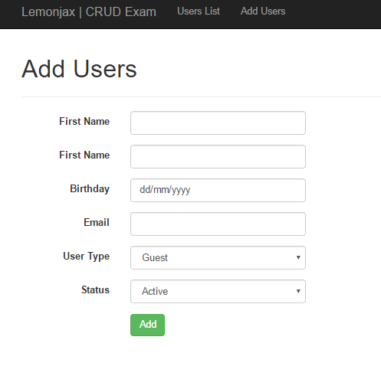

1. The page should Redirect into Default.aspx where the table should reflect the records inserted into the database.
2. Proceed to “Default.aspx”
3. Here, you are tasked to create proper databinding codes using <%# Eval(" ") %> inside

Each <td></td> clauses. The Overall template is already provided such as the drop down list, search box and buttons and table headers.

1. In the code behind file of the form, Default.aspx.cs, Proceed into creating proper database SELECT command text to get records from the database. The method GetUsers(string keyword) has already been provided.
2. In creating the SELECT statement, make use of LIKE '" + keyword + "%' for each database column that the search box will look at.
3. Similarly, in the WHERE clause of the SELECT statement, the drop down list (ddl) should also be used to filter user types for Guest and Client.

